Digital Design Principles

Shift Register

Name: Rajkaran Singh Grewal

Student No: 8882386

Email: rgrewal2386@conestogac.on.ca

Objective:

- Design a parallel load, left and right shift register.

VHDL Introduction:

To make the program in VHDL we will need to initialize the library and entity. Within the entity we will have the following inputs, a standard logic vector of 6 bits for the switch inputs, a standard logic vector of 2 elements for the choice of null, load, shift right and shift left, a standard logic for the push button. For the outputs we will have 4 standard logic vector of a total length of seven elements for the seven segment display, and we will have a standard logic for the led light to let us know that the push button is pressed. Within the architecture we will have the following logic, we will initialize two elements one will be an integer to store the counter value. And the next value will be a standard logic vector which stores 4 elements will represent the four elements we will be manipulating. In the process we will check if the push button is pressed and if it is pressed than we will light up the led, and then check if the counter value is less than one. If it is than we will increment the value of count by one and use a case statement to check if the choice is one of the following options where when choice represents both 0 than nothing will be done. If the second element is high than we will shift the load element to the left by one, and add the value in switch 0 to the last element. In the case of the first element is only high than we will shift the load Element by one to the right and add the value in switch 5 to the first element. For the case of both elements are high than we will load the values in switch 4 to 1 to the load Element. After the if statement that checks if the count is less than one, we will set the seven-segment display with the correct representation of the value so if it’s a 0 it will show a zero, and if it is a one than it will show a one. And after the if statement where we check if the push button is pressed, we will finish the program with an else statement where we set the led to low and the count back to zero.

VHDL program screenshot: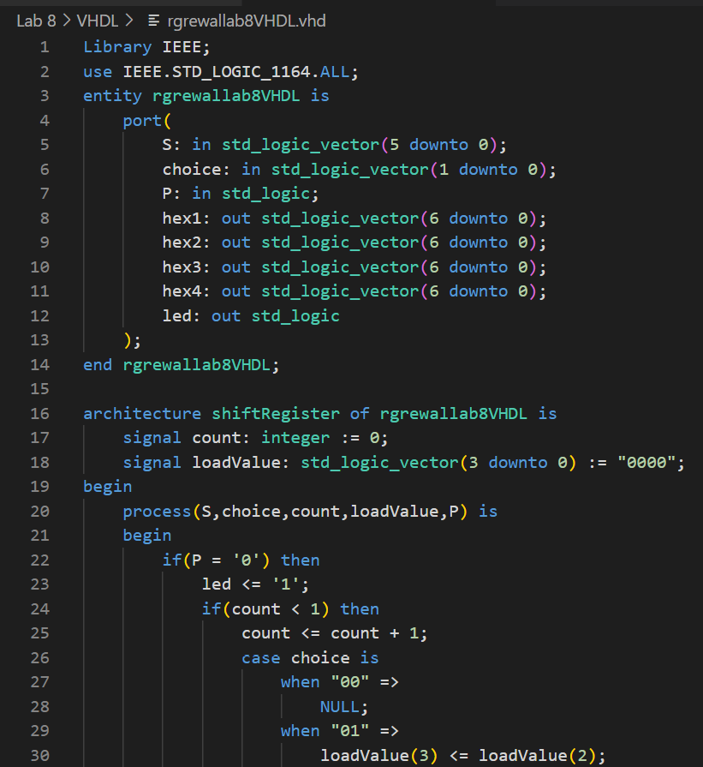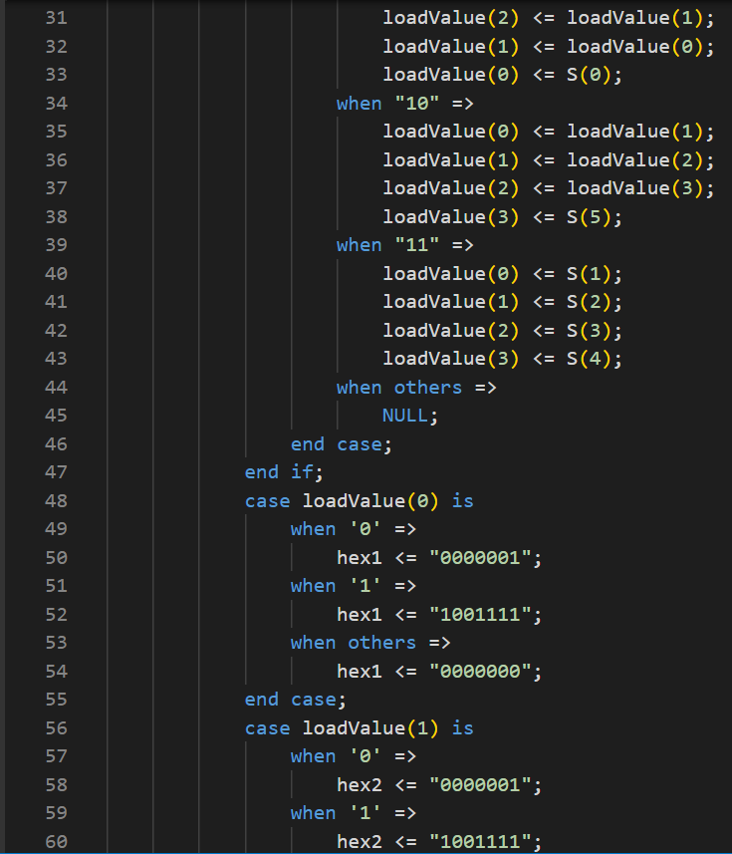

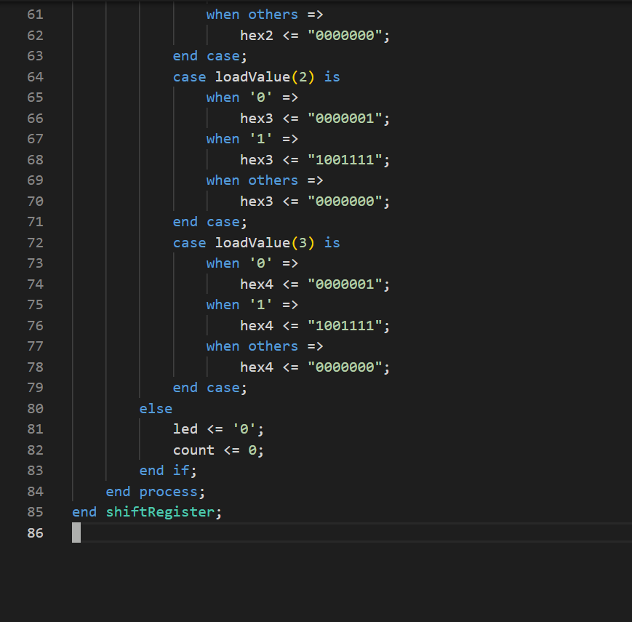

VHDL compilation report: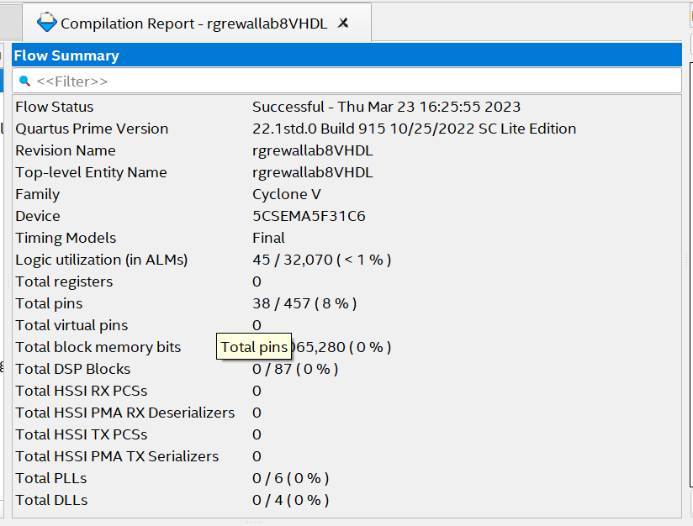

Pin Planner screenshot:

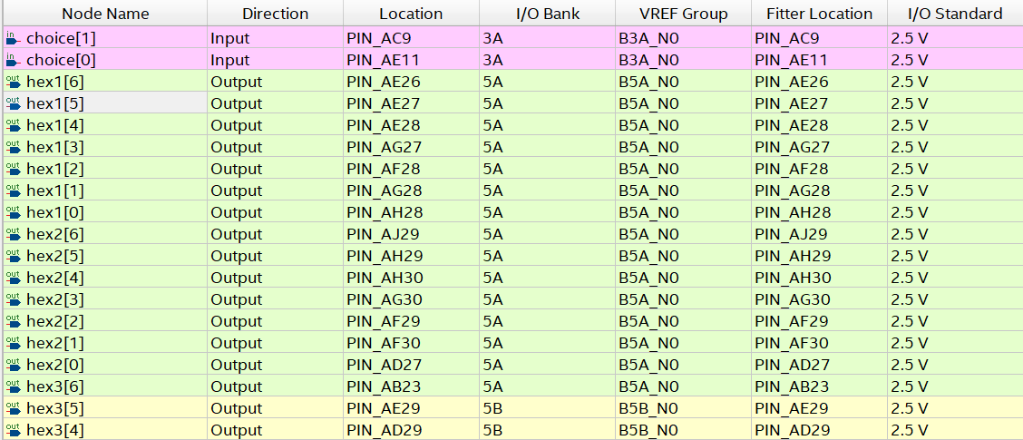

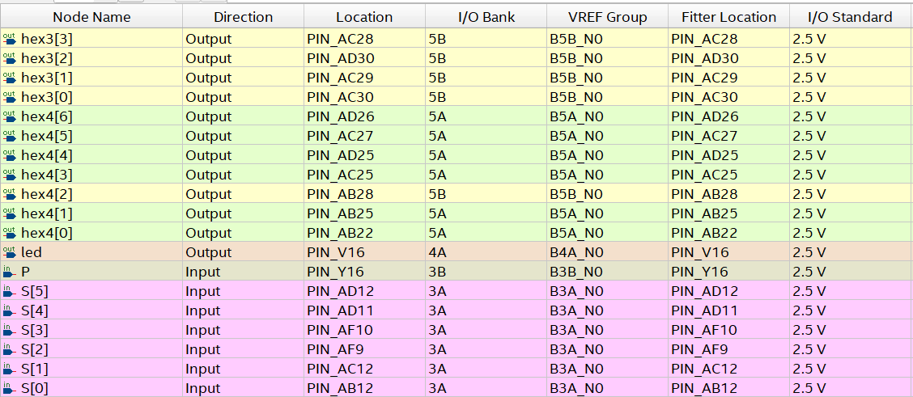

Verilog introduction:

For the program in Verilog we will need to initialize the module with the parameters having the following inputs, first of all we will have an array of 6 elements that will represent are switches, than we will have array of two element which will store the value for our choices, that can be null, shift left, shift right, load. We will have the input for the push button. Next for the outputs we will have four array which can store seven elements, this will represent our four seven segment displays. And finally, we will have an output to store our led value.

For the logic we will initialize an array of four elements to store our load-value. We will also initialize an integer to store our count value. Within the always, we will check if the push button is pressed using a if statement, for the condition we will light up the led and increment the count by one. We will check if the count is equal to 0 with an if statement. Then with the if block we will use a case statement to check what choice has been provided. If both choices are zero than we will do nothing, if the last element is high and the other element is low than we will shift the load-value to the left and add the value in switch zero to the last element in load-value. If the case is high for the first element and low for the second element, we will shift the elements to the right and insert the value of switch 5 to the first element. For the case where both element is high than we load the value of switch 4 to 1 to the load-value. After the if block which checks if the count value is less than zero we set the values of the seven segment display according to the load-value. After the if block of which checks if the push button is pressed, we will have an else block where the led is set to low and the count is set to zero.

We will also include a function where the value which is return is an array of seven segments and the input is a character. The character will be check using a case statements where the output will be the highs and lows value to set the seven segment displayed.

Verilog program screenshot: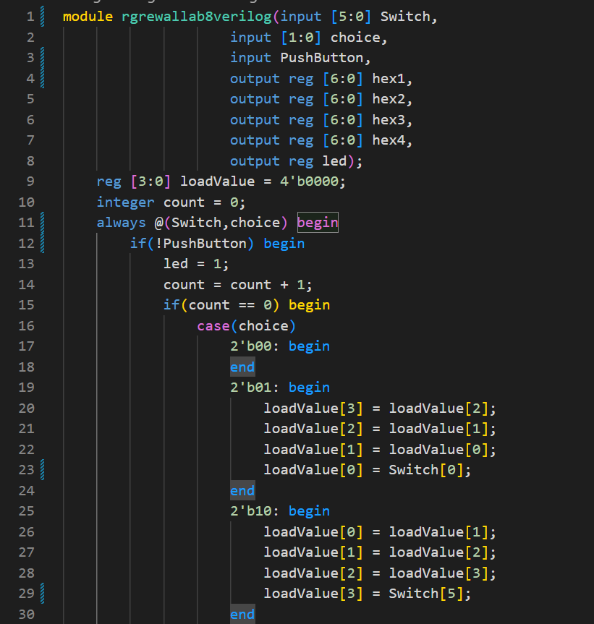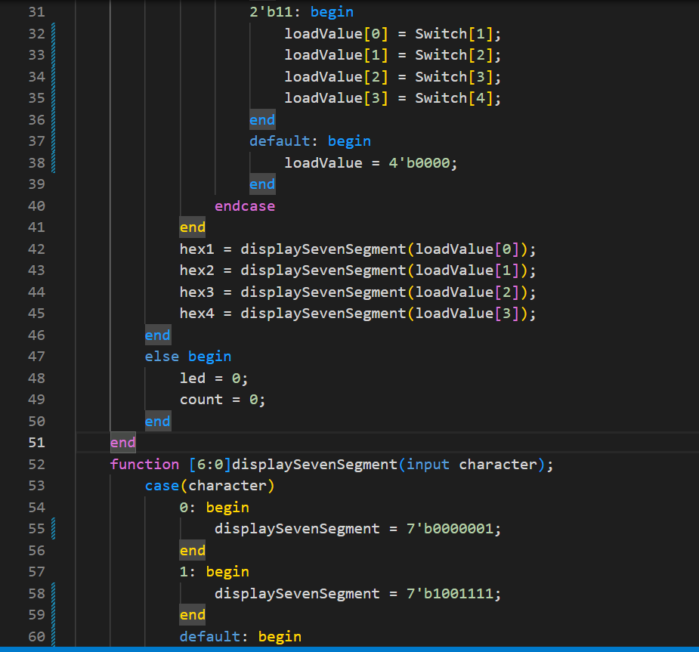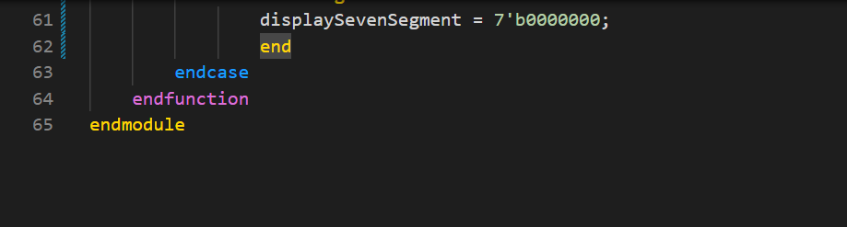

Verilog compilation report: 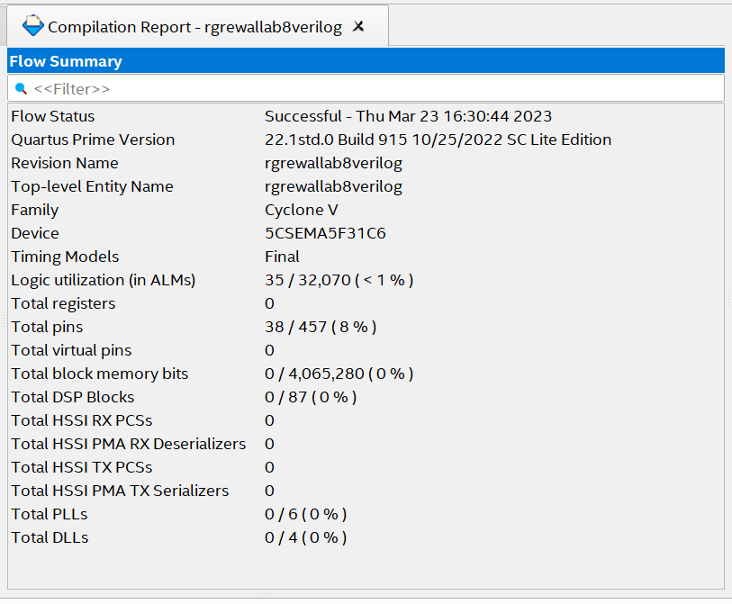

Verilog pin planner screenshot: 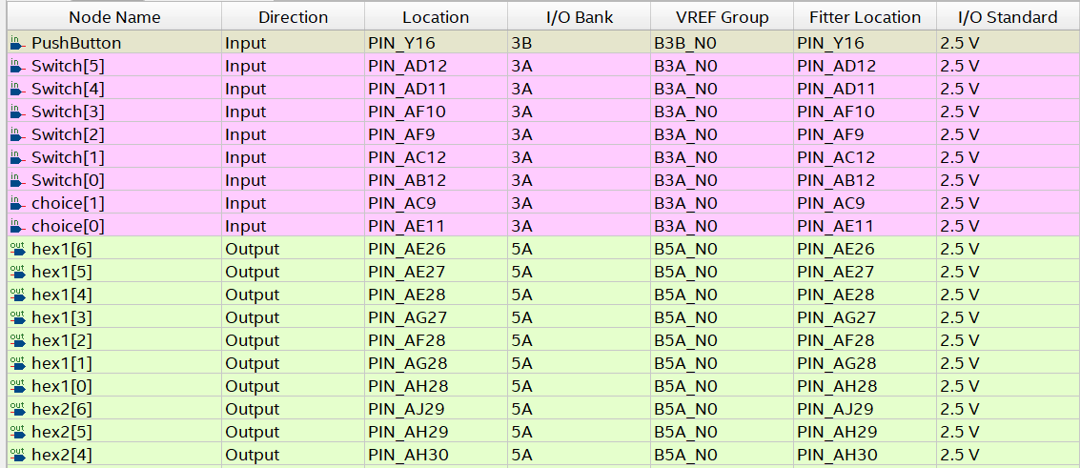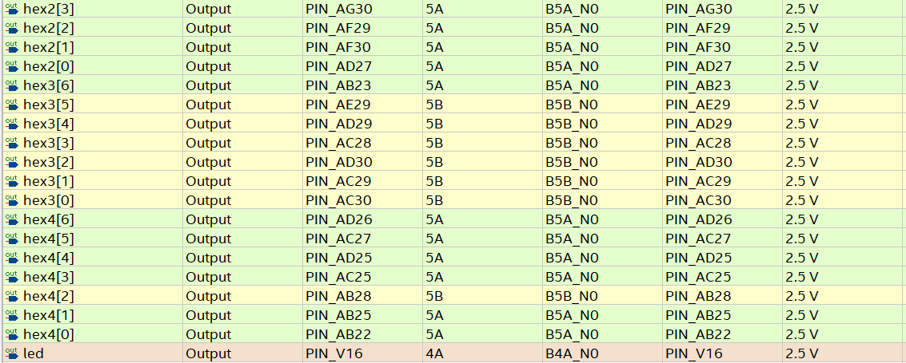

Conclusion:

Thus we can conclude that by both the programming languages we will check if the push button is pressed and if the counter is less than 1 than we will use case statement and set the load-element according the requirement of the objective. We will finially set the seven segment display to the load-element to show us how the shift register works.